Curriculum Vitae
personal Information
Name | Nawal Ahmed Abd Elganii Noor | 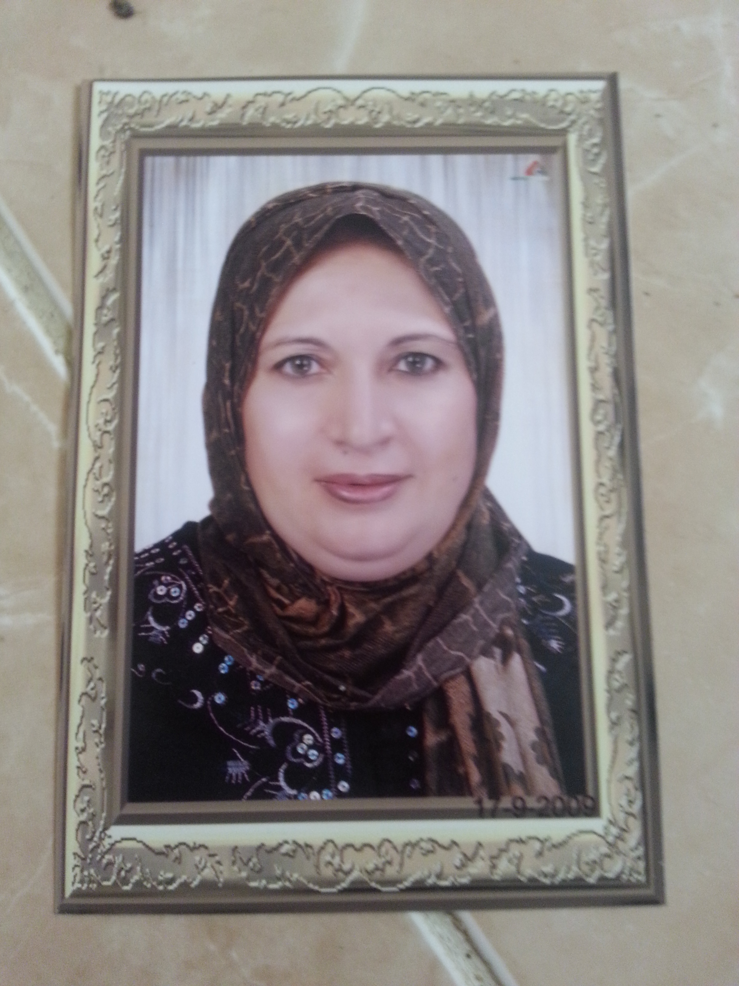  optional photo
Title | Assistant Professor of Anatomy and Embryology, Faculty of Vet. Med Cairo Univ.
Date of birth | 28/ 12 / 1959
Place of birth | Dakahlia, Egypt
Citizenship | Egyptian
Contact Information
Home phone | 0238210778
Work phone | 0020235720399/ 002023572047 Fax: 0020235725240
Mobile phone | 01116113130
E-mail (s) | Ahnour2011@yahoo.com
Web site (s)
Current Address | Faculty of Veterinary Medicine, Cairo University, Giza
Educational Qualifications
Ph. D., Faculty of Veterinary Medicine, Cairo University, 1995
M. Sc., Faculty of Veterinary Medicine, Cairo University, 1989
B. Sc., Faculty of Veterinary Medicine, Cairo University, 1983
Academic Positions
Assistant Professor, Anatomy&Embryology Dep, Faculty of Veterinary Medicine, Cairo University, 2018
Lecturer Anatomy&Embryology, Department, Faculty of Veterinary Medicine, Cairo University, 1995
Assistant Lecturer, Anatomy&Embryology , Faculty of Veterinary Medicine, Cairo University, 1989
Demonstrator, Anatomy&Embryology , Faculty of Veterinary Medicine, Cairo University, 1983
Thesis Title
M. Sc. Anatomical studies of the female genital system of rabbit
Ph. D. Some anatomical studies on the spinal cord of the goat with special refrenceses to its meninges and vascularization |  |  | Some Anatomical studies on the pharynx of the one humped Camel in comparison with that of Bovines
Areas of experience
Projects
Awards
Professional Qualifications
Conferences

Training courses
-Modern methods for teaching
- Using Technology in teaching program.
- Skills for effective presentation.
- Teaching evaluation.
- Credit hours system.
- Exams and students evaluation.
- University administration.
- Quality in teaching process

Computer Skills
Icdl

Language Skills
English
Professional Memberships
MEMBER OF THE EGYPTION VETERINARY MEDICAL ASSOCIATION
MEMBER OF EGYPTION SOCIETY OF ANATOMY
MEMBER OF EGYPTION SOCIETY OF HISTOLOGY
MEMBER OF THE EGYPTION VETERINARY MEDICAL SYNDICATE

Other activities
- Shared in the teaching of theoretical and practical courses of anatomy and embryology for both of the undergraduate and postgraduate students in the department of anatomy and embryology. In addition , shared in the summer training course for the undergraduate student. participated with the professors and colleagues in the conduction of research activities. In the meantime, also cooperates with researchers at different departments and collages to perform collaborative research in the different fields of Anatomy and also shared on several national. In addition to share in reconstruction of the anatomy museum and introduces a new education trend (self-learning) using learning carrels or modules.
- Design of several Anatomical specimen and educational aids assigned for the teaching process.
- Academic supervision and pioneering of undergraduate and postgraduate students at the faculty.

List of publications

1- Samah. H. El-Bably, Nawal. A. Noor (2017):ANATOMICAL, RADIOLOGICAL AND MAGNETIC RESONANCE IMAGING ON THE NORMAL STIFLE JOINT IN RED FOX (VULPES VULPES). International Journal of Anatomy and Research, Vol 5(4.3):4760-69 . ISSN 2321-4287 www.ijmhr.org/ijar.htm.

2 Nawal. A. Noor, Samah. H. El-bably(2018):-Anatomical Studies on the arterial Supply of the Eye in the One- Humped Camel (Camelus dromedarius). International Journal of Anatomy and Research , Vol 6(1) ISSN 2321-4287 (O) & ISSN 2321- 8967 (P) www.ijmhr.org/ijar.htm.

3-Nawal, A. Noor and Maher, M.A.(2018):-Gross Anatomical, Radiographic and Ultra-structural Identification of Splenic Vasculature in some Ruminants (Camel, Buffalo Calf, Sheep and Goat. Int. J. Adv. Res. Biol. Sci. 5(2): 44-65 : www.ijarbs.com /
ISSN: 2348-8069.

4- Nora A, Shaker and Nawal A Noor(2017): Morphological Features of the Bones and the Arterial Supply
of the Wing in the Hooded Crow (Corvus cornix) with Special Reference to the Muscles of Flight International Journal of Veterinary Science .
, 6(2): 96-103. www.ijvets.com; editor@ijvets.com P-ISSN: 2304-3075; E-ISSN: 2305-4360 .

5- Nawal, A, NOOR and Amr, F, ELKARMOTY(2018): Anatomical, Radiographical and Magnetic Resonance Imaging Features of Normal Temporomandibular joint (TMJ) in Camels (Camelus dromedarius): A Special Reference to TMJ Surgical Approach.
Int. J. Adv. Res. Biol. Sci. 5(2): 34-43: www.ijarbs.com / ISSN: 2348-8069.

6- Elkarmoty AF and Nawal A Noor Macromorphological Study on the Tongue of the Red Fox (Vulpes vulpes) with Special Reference to Its Arterial Supply.
Inter J Vet Sci, 6(3): 144-152. www.ijarbs.com/ E-ISSN: 2305-4360.
7- Khalifa, E.F and Nawal, A. Noor(2017):Anatomical study on the testicular artery of bull (Bos Taurus). Int. J. Adv. Res. Biol. Sci. 4(2): 80-89 www.ijarbs.com / ISSN: 2348-8069.

8- Nawal A. Noor, M.A. Al-Ayat, G.A. Swielim and G.M. Alloush(2015):Pattern of Distribution of the Cardiac Veins of the Heart of Goat Advances in Biological Research 9 (6): 449-466,
ISSN 1992-0067© IDOSI Publications, DOI: 10.5829/idosi.abr..9.6.449.466 .

9- Nawal A. Noor (2017): Macroanatomic investigations on the course and distribution of the celiac artery in Hooded crow (Corvus cornix) with special reference to the arterial supply of the stomach JOURNAL OF VETERINARY MEDICAL RESEARCH, 24 (1): 277-289 http://www.bsu.edu.eg/bsujournals/JVMR.aspx Online ISSN: 2357-0520 Print ISSN: 2357-0512

Publications statistic
Journal’s Publication |  | Conference’s Publication |  | Authors |  |  | Total
Local | International | Local | International | Single | Shared |  | Total
 |  |  |  |  | Internal | External | Total
7 | 2 |  |  | 1 | 8 |  | 9

